- FTP & SNMP NETWORK MANAGEMENT ASSIGNMENT
Q1. Install FileZilla Server on your Windows machine, create a user account, and set up a shared folder for FTP access.
Aim
To install FileZilla Server on Windows, create an FTP login, and give the user access to a shared folder for file transfer.
Procedure
1. Download and install FileZilla Server on the Windows computer. During setup, keep the local administration interface port at its configured value (the screenshot below shows 14148).
2. Open the FileZilla Server Administration Interface and connect to the local server at 127.0.0.1.
3. Open Server > Configure (or the server settings window), then go to Rights management > Users.
4. Click Add and create a user account. In the real screenshot below, the user account displayed is “dilpreet”.
5. Choose “Require a password to log in” and set a password for the FTP user.
6. Create a Windows folder to use for FTP sharing, for example C:\FTP_Shared.
7. Under Mount points, add the shared folder as the native path and map it to the virtual path /. Set the access mode to Read + Write and allow directory browsing as required.
8. Click Apply / OK and make sure the server is running and ready to accept FTP connections.
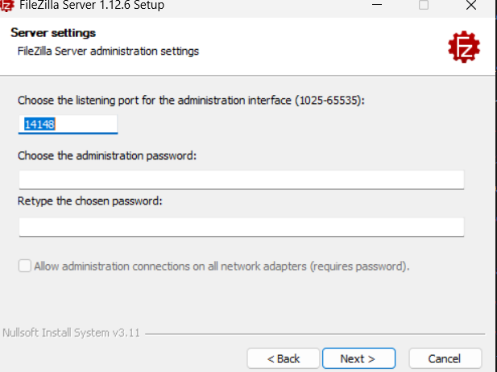

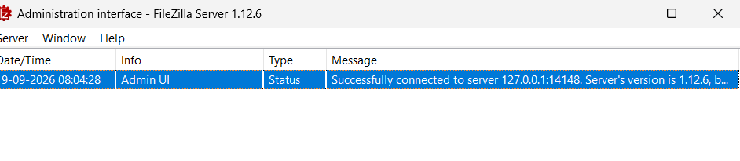
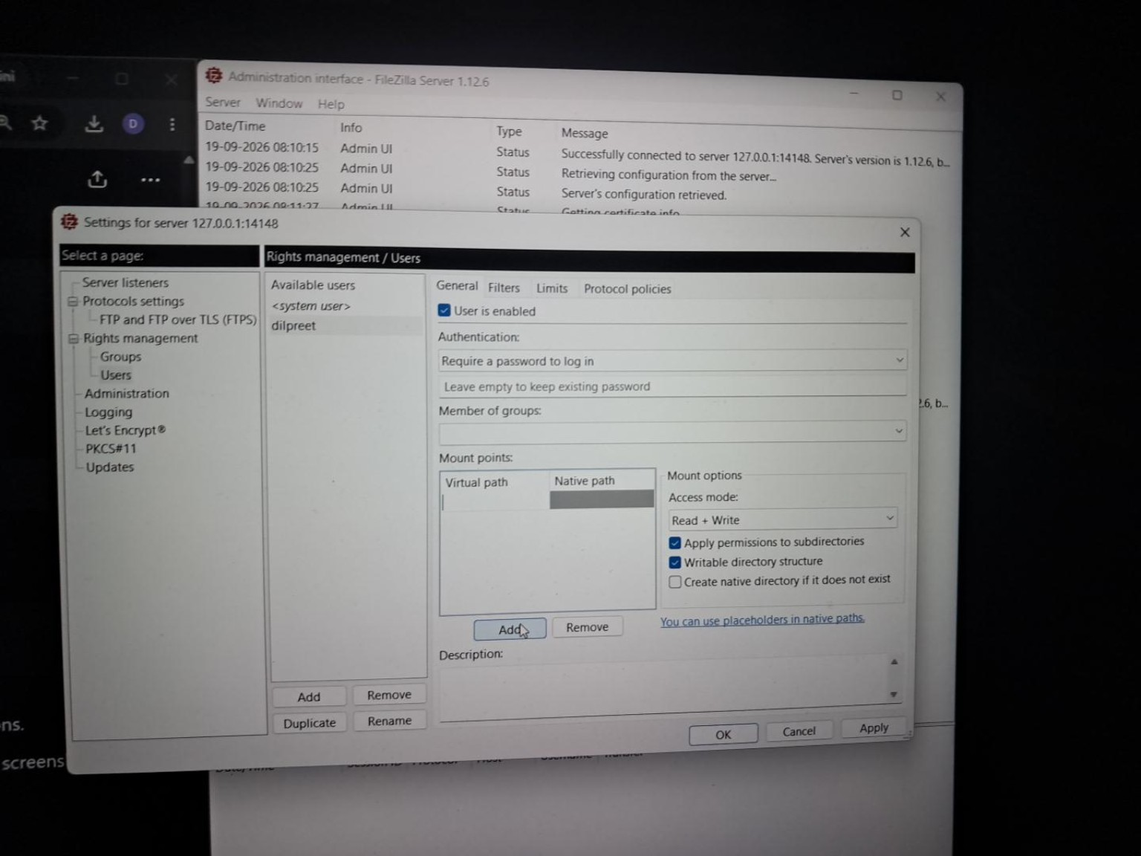
Result
FileZilla Server is ready for FTP access after the user account, password, shared folder (mount point), and required Read/Write permissions are configured.

Q2. Use FileZilla Client to connect to your FTP server using the credentials you created, and upload any image file from your computer to the shared folder.
Procedure
1. Install and open FileZilla Client.
2. In the Quickconnect bar, enter Host: 127.0.0.1 when the Client and Server are on the same Windows computer.
3. Enter the FTP username and the password created in Q1.
4. Enter Port: 21 for a normal FTP connection and click Quickconnect.
5. After login, the left side of FileZilla Client shows Local site files and the right side shows the Remote site (FTP server).
6. Browse to any image on the Local site, such as a JPG or PNG file.
7. Drag the image from Local site to Remote site, or right-click the image and choose Upload.
8. Check the message log / Successful transfers tab and confirm the image appears in the remote shared folder.
Connection item | Value to use
Host | 127.0.0.1 (same computer)
Username | The FTP user created in Q1
Password | The password set in FileZilla Server
Port | 21
Observation
When the upload is successful, the image is visible in the Remote site pane and the transfer is listed as successful. The FileZilla Client interface uses a Local site pane for the computer and a Remote site pane for the FTP server.
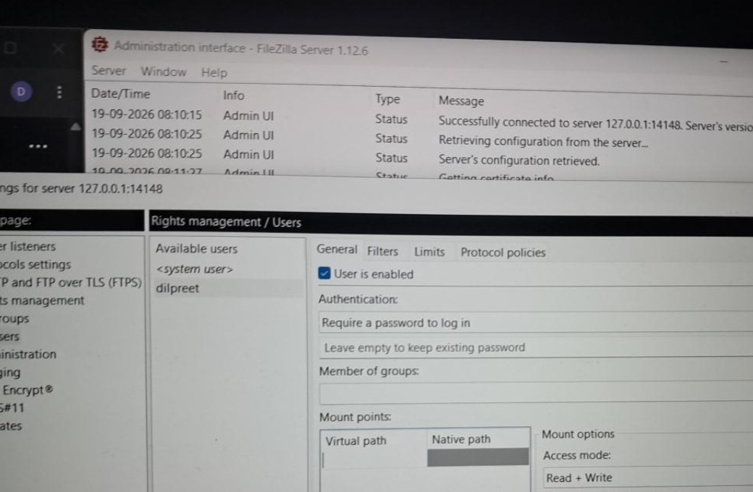
Q3. Download the uploaded file from your FTP server to a different folder on your computer using FileZilla Client, and verify the file size matches the original.
Procedure
1. Create a different local folder, for example C:\FTP_Download_Verification.
2. In FileZilla Client, browse the Local site pane to this new download folder.
3. In the Remote site pane, locate the image uploaded in Q2.
4. Right-click the remote image and choose Download, or drag it from the Remote site pane to the Local site pane.
5. Wait until the transfer appears under Successful transfers.
6. Right-click the original image in Windows File Explorer > Properties and note its Size in bytes.
7. Open Properties for the downloaded copy and compare the Size value. The two values should be identical for a correct transfer.
Verification item | Record your value
Original file name | ____________________________
Original size (bytes) | ____________________________
Downloaded size (bytes) | ____________________________
Size matches? | Yes / No
Result
If both files show exactly the same byte size, the downloaded file matches the original in size and the FTP transfer is verified.
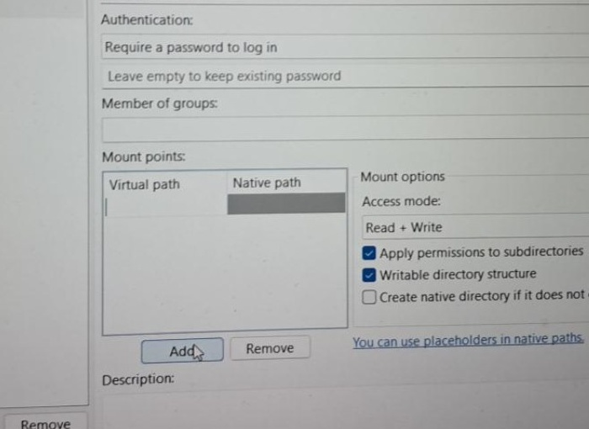
Q4. Research and list 3 real-world scenarios where SNMP is used in network management for apps or services you use.
1. Internet Service Provider (ISP) network monitoring
ISPs can use SNMP-based network management systems to monitor routers and switches. Administrators can check whether interfaces are up or down, watch interface traffic/bandwidth counters, receive link alerts, and identify overloaded or faulty links. This helps maintain internet service availability.
2. College / campus Wi-Fi monitoring
Campus IT teams can use SNMP to monitor wireless access points, controllers, and switches. Monitoring platforms can track device reachability, AP status, connected-client information, bandwidth use, CPU/memory values, and alerts. This helps the team find a failed or overloaded access point quickly.
3. Large website or data-centre network monitoring
A data-centre operations team can use SNMP to monitor network infrastructure that supports websites and online services, such as routers, switches, firewalls, and other SNMP-capable equipment. Common checks include uptime, link status, traffic counters, errors, CPU/memory values, and SNMP traps/notifications when faults occur.
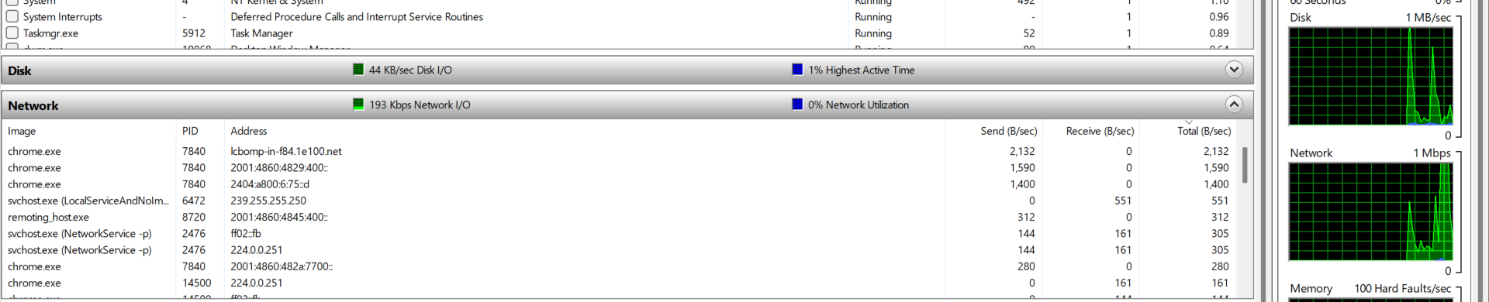
Figure 6: Real Windows Resource Monitor network-activity screen. SNMP monitoring systems collect similar interface-traffic, utilization and device-health information from network equipment.
Research references
• Cisco documentation: SNMP MIB / IF-MIB interface monitoring and linkUp/linkDown notifications.
• HPE Aruba AirWave documentation: monitoring wireless devices, AP status, bandwidth, CPU and memory.
• HPE Aruba Central documentation: SNMP monitoring and SNMP traps for network devices.

Q5. Create a table comparing FTP and HTTP across at least 5 points: port number, security, data transfer method, use cases, and authentication.
Point | FTP | HTTP
Full form | File Transfer Protocol | Hypertext Transfer Protocol
Default port | TCP 21 for the FTP control connection. FTP uses separate data connections for file transfers. | TCP 80 for HTTP. HTTPS normally uses TCP 443.
Security | Basic FTP sends commands and credentials without encryption. FTPS adds TLS encryption. SFTP is a different protocol that runs over SSH. | Basic HTTP is not encrypted. HTTPS protects HTTP traffic using TLS.
Data transfer method | Designed for file upload/download, directory listing, and file management. Traditional FTP uses a control connection plus separate data connection(s). | Uses a request-response model to transfer web pages, API data, images, videos, files, and other web resources.
Common use cases | Moving files to/from an FTP server, file exchange, backups, and some hosting workflows. | Web browsing, web applications, REST APIs, downloading web content, and online services.
Authentication | Commonly uses username/password and may allow anonymous FTP if the server permits it. | Depends on the website/app: login sessions, cookies, HTTP Basic/Digest, bearer tokens, OAuth, etc.
File/directory management | FTP includes commands for listing, uploading, downloading, renaming, and deleting files/directories when permissions allow. | HTTP mainly accesses or submits resources; it is not normally used as a general remote-file-system management protocol.
Conclusion
FileZilla Server provides the FTP service and user permissions, while FileZilla Client is used to connect, upload, and download files. SNMP is mainly used for monitoring and alerting on network devices. FTP is focused on file transfer and file management, while HTTP is the main protocol used to deliver web content and web application data.
Sources consulted
• FileZilla Project - FileZilla Client and FileZilla Server documentation/screenshots: https://filezilla-project.org/
• Cisco - SNMP / MIB and IF-MIB network interface monitoring documentation.
• HPE Aruba Networking - AirWave wireless-device monitoring documentation.
• HPE Aruba Networking - Aruba Central SNMP monitoring and trap documentation.
• RFC 959 (FTP) and RFC 9110 (HTTP semantics), RFC Editor.

